The Jackson Pad
Impact Isolating Drum Platform

Illustrated Builder's Guide – REVISION 1 (Includes Larger 60x72” Size)

About This Document

This Builder’s Guide is a pictorial documentation of the construction for the original Jackson Pad prototype. It is a companion to the dimensioned design documents.

Preface

"Music has charms to soothe a savage breast." - William Congreve.
Also written by our pall Bill was the line "Heaven has no rage like love to hatred turned, Nor hell a fury like a woman scorned." And as some drummers have learned, enraging our wives and significant others may indeed yield rage, and possibly a savage breast.

We live in a 3-dimensional world, and drums make noise. Though electronic drums produce much less airborne noise than do acoustic drums, certain aspects are identical. Kick pedals are the primary offenders of lower neighbors, and this document thus serves as the blueprint for a peace treaty.

First off, we are not treating acoustic noise. That is an entirely different field of study. This document is only for the isolation of hard impact force from kick pedals and other downward momentum. Though there are areas where impact and sound isolation intersect, we're only going to discuss impact.

The Jackson Pad's 3 design criteria:

It must be 100% effective as-is, without adjusting or experimenting. Period.
It must be simple to assemble, using only off-the-shelf, readily available items.
It must be cost effective, and require no investment of specialized tools.

One popular DIY method of impact isolation is the “Tennis Ball Riser.” A Google search reveals a plethora of information on this design. In certain circumstances it has proven reasonably effective, but in others it's been a hit-or-miss affair. As such, it was decided from the onset to aim for a guaranteed solution and, if possible, achieve a greater degree of building simplicity and cost-effectiveness.

Having built and tested the prototype, the result is a super-simple design that has proven to meet all the above criteria. Because of its success, this builder’s guide and accompanying plans (PDF) are being published openly for free distribution to the drumming community.

Why It Works
The heart of the design is the “Isolation Pedestal”, of which there are 4. These are stacked concrete patio pavers that provide very high inertial mass, which are divided into two groups. The two groups are separated by a wheelbarrow inner tube that decouples the upper mass, and redirects most transmitted energy outward horizontally… the path of least resistance.
High inertial mass is necessary because vibration and impact noise is the result of something physically moving. And like electricity, it can be conducted through contacting objects, like floors and other building structures.

Because it’s impossible to completely decouple an impact source from its supporting structure (until anti-gravity mats are invented anyway), one way around this is by making the system resistive to impact force. Imagine a golfer getting ready to drive a golf ball into the distance, except we’ve replaced the golf ball with a bowling ball. The kinetic energy of the club head is the same when it strikes either ball, but unlike the golf ball which sails freely, the bowling ball barely moves. The difference is inertial mass. That's why big heavy things suck at being jiggled rapidly. They need a lot more energy to move them, and your foot will only supply so much.

In this design there is also a dampening element (the inner tube). Since mass alone cannot completely prevent all impact transmission, the damper serves to absorb and dissipate what little energy does make it through the upper mass. Besides being a very poor conductor of impact energy, pneumatic (air) dampers convert kinetic energy into heat energy. When you suddenly compress a volume of air, the same latent heat is now occupying a smaller space. This is why air compressor tanks get hot when they’re being pressurized.

As is with all energy conversion, radiated heat will always rob the system of being 100% efficient, and in this case, that is exactly what we want.

The lower portion of the isolation pedestal is the 2nd mass group, and further resists the tiny residual impact force that makes it through the upper group and damper.

Another Consideration

The Jackson Pad platform uses a slatted design instead of plywood, MDF or other “square foot-measured” sheet material. Air gaps through the platform surface prevent a “plosive wave” from being produced under it, directed at the floor, which might have rendered the design ineffective. Plywood and other continuous surface materials can behave like soundboards or subwoofers.

The following is a step-by-step pictorial of the assembly of our prototype. Please refer to the accompanying PDF design documentation drawings*** for exact dimensions and layout.

(***Use the Revision 1 construction drawings if you are building the larger 60x72” version of the platform)
Cutting The Lumber

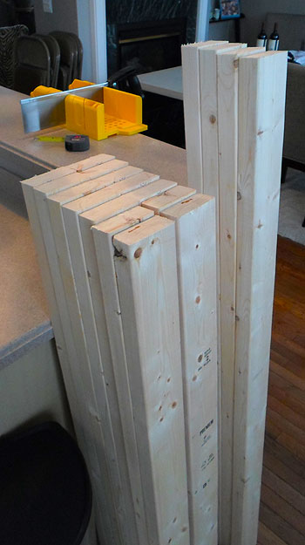
Standard ‘grade 2’ framing studs are cut to length. A hand saw and miter box (pictured) was more than adequate if a powered saw is unavailable. Since the prototype platform needed to be 48” deep, 8-foot studs could be cut in half to make the slats. For the 60” deep riser you can purchase studs in 10’ lengths. If possible, pick the straightest lumber you can with the fewest knots. It will be easier to work with.

Revision 1 Note: The bill of materials on the last page has been appended to include the 60” deep (R1) version of the Jackson Pad. Stud lengths and quantities are different than the original (R0) version.

Measuring Slat Spacing

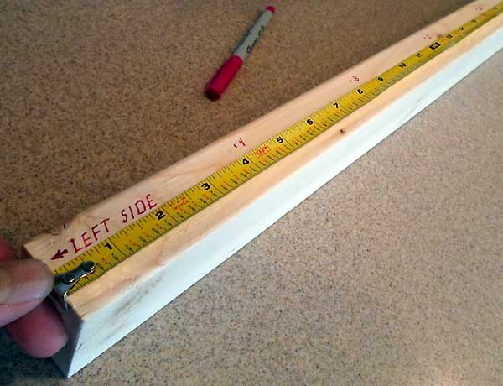
Once you’ve cut your trusses to length and established which “pretty” sides you want facing out, mark the tops of both the front and rear trusses every 4”, starting from the left side. These marks will be the alignment points for the slats.

Squaring and Layout

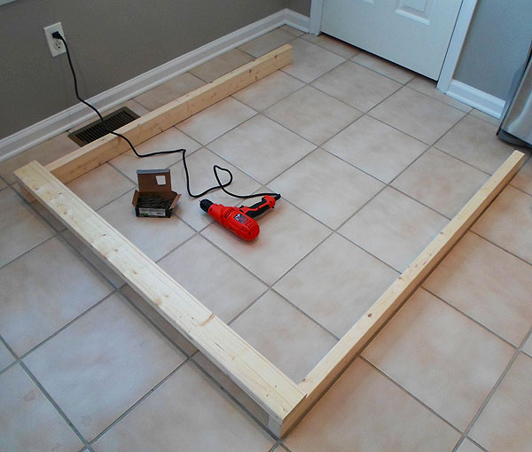
Though it’s not imperative your platform be exactly square, you can usually find items or features around to help with layout. For the prototype, floor tiles were a convenient means of visual squareness. You can also tape measure both diagonal distances and adjust until they are equal.

Slat Spacing

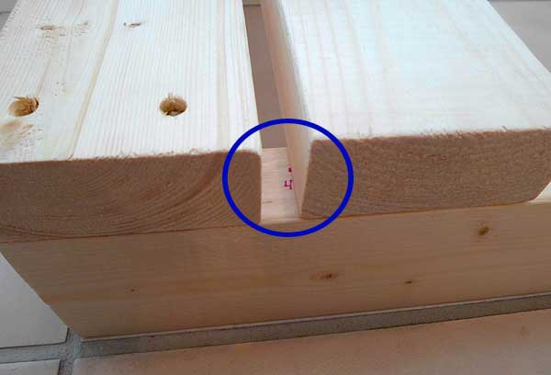
Since the slats are 3-1/2” wide, a ½” air gap is created when they are spaced 4” apart. Line up both ends of the slats with the marks you made earlier on the front and rear trusses. Screw slats to trusses with 2-1/2” or 3” deck screws. 2 screws at each end. Start screws about 1” from the ends of the slat to help prevent splitting the wood.

Slat Attachment

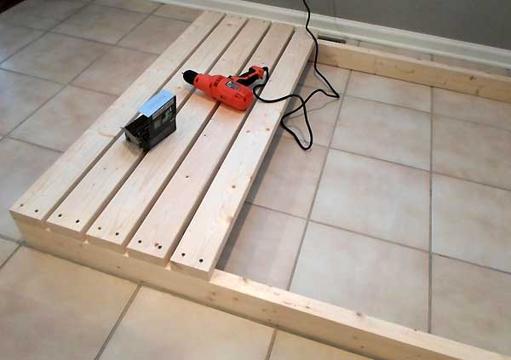
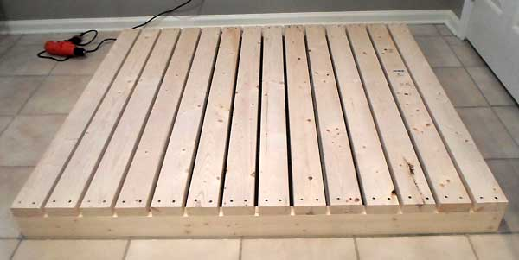
Note there are 2 screws at each end of every slat.

Note: Original size shown. The larger 60x72” has 4 additional slats.

Truss Attachment Preparation and Spacing

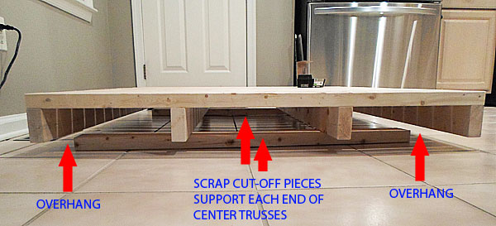
To attach the 2 center trusses, it’s recommended to use some scrap lumber to elevate the platform such that it is only resting on the center trusses, with the outer trusses suspended. That way they are making contact with the slats when fastening in case the floor sags in the middle. There should be 13” of clear space between the outer and inner trusses. This allows the impact pedestals to nest between them, as shown below.

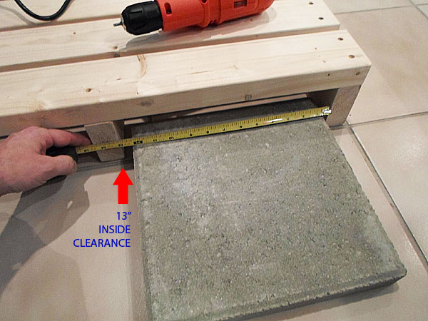
Frame Cosmetics

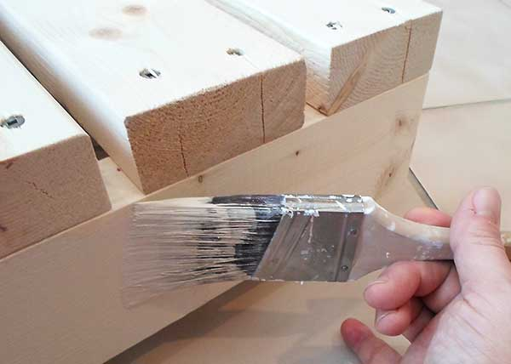
If you wish to paint the exposed outer surfaces of your platform, leaving it on the scrap lumber supports elevates it from the floor to make life easier.

Carpet Cutting

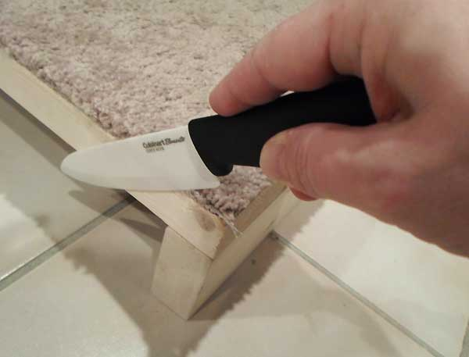
If you wish to carpet the top of the platform, consider using a ceramic bladed knife if you have access to one. It proved to be much easier to slice cleanly and quickly than a utility knife or shears. Up and down slices, using the edge of the platform as a blade guide, provided the cleanest results on the prototype.

Carpet Fastening

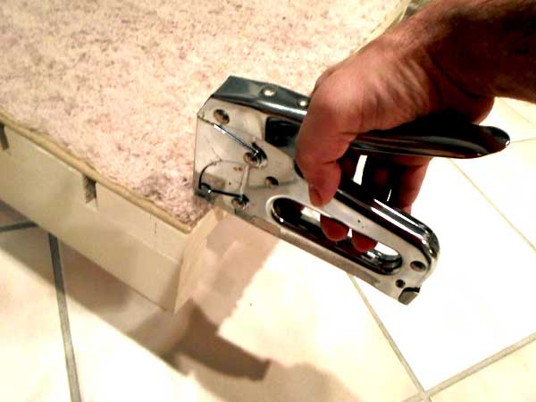
Staple or tack the carpet around the perimeter of the frame. There is no need to fasten in the middle.

Stacking and Positioning the Isolation Pedestals

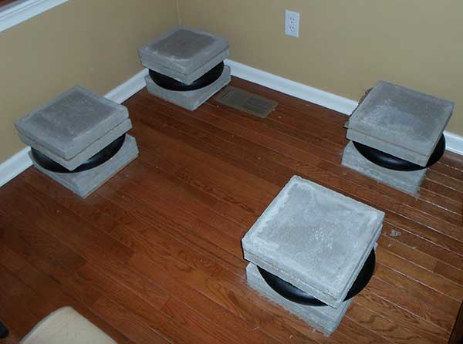
Refer to the accompanying Design Documentation drawings (PDF) for stack sequence and spacing. If on hardwood floor, stack them on 12" carpet squares. Position the pedestals to support the platform as per the design documentation. If your platform dimensions are different from the plans, make a note and adjust the pedestal spacing accordingly.

The upper blocks will be rather wobbly at this point. This is normal, as they will become rather rigid under load when the platform is overlaid.

The inner tubes should NOT be inflated to any significant pressure. Around 5 PSI is desirable, or enough that you can pinch the sides of the tube together with your finger strength. It should only barely register on a standard sliding-scale tire pressure gauge.

When the platform is loaded, the inner tubes should compress to around 2” thick.

The upper blocks, inner tubes and lower blocks should all be centered and aligned vertically as columns. Make sure the inner tube overhang is the same on all sides.

NOTE: Inner tubes stink! If possible, purchase them a few days in advance and let them vent off their odor outdoors, lest you become very unpopular with your family or room mates.
Installing the Platform

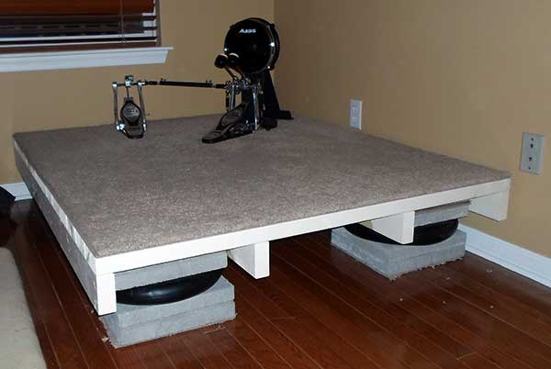
Get a friend to help you with this part… it's heavy. Lay the platform onto the pre-positioned pedestals top-down rather than sliding as to avoid shifting the upper pavers out of alignment.

Intense jumping, bouncing, pounding and sledge impacts on the platform surface could not produce any significant impact noise in the rooms below and adjacent. We tried. The combined effects of mass and dampening did their job as designed, and remarkably well.

The Finished Results

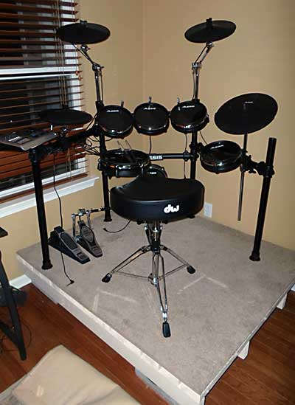
Congratulations, and enjoy your newfound freedom!

You will notice that there is some movement in the pad when standing or playing. This is normal, but it does not wobble or bounce in a disruptive way. It feels rather like a car suspension.

If you find this information helpful, please share this document and the accompanying Design Documentation drawings (PDF) with other drummers. Thank you for your interest, and happy drumming.

Respectfully,
Brian Jackson

Bill Of Materials and Cost – Original R0 version:

Lumber (for original version R0)
2 X 4” (1.5 X 3.5” actual) #2 Grade, 8' length @ 2.10 ea. - 11 required = $23.10

Concrete Patio Stones
12 X 12 X 2” @ $1.56 ea. - 16 required = $24.96

Inner Tubes
4.80 X 4.00-8 for 8” rim, puncture self-sealing @ $9.97 ea. - 4 required = $39.88

Wood Deck Screws
2.5” or 3” 1-lb box @ $3.99 ea. - 2 boxes required (112 screws total) = $7.98

Total Cost: $95.92

Carpet was not calculated in the total cost because it is usually possible to find scrap sufficient for this size project.

All items are standard stocked products available at most big-box home improvement stores. Lowe's and Home Depot are recommended. Note that the inner tubes were only stocked at Lowe's.

For the larger 60x72” R1 version:

Lumber (for larger version R1)
2 X 4” (1.5 X 3.5” actual) #2 Grade, 8' length @ 2.10 ea. - 4 required (for trusses)
2 X 4” (1.5 X 3.5” actual) #2 Grade, 10' length @ 2.10 ea. - 9 required (for slats)

